A Sense of Presence: Improving Citizen Science Water Quality Monitoring through Virtual Reality Immersive Training

|  | Alina Goldman  University of Maryland  College Park, USA  Algol001@umd.edu |  |
| --- | --- | --- |

# ABSTRACT

Permission to make digital or hard copies of part or all of this work for personal or classroom use is granted without fee provided that copies are not made or distributed for profit or commercial advantage and that copies bear this notice and the full citation on the first page. Copyrights for third-party components of this work must be honored. For all other uses, contact the Owner/Author. Copyright is held by the owner/author(s).

Every submission will be assigned their own unique DOI string to be included here.

Citizen science, a method of data collection and analysis by volunteers to improve scientific research, is an emerging topic in information studies **(ref).** Citizen science has the capacity to improve its reach and effectiveness, but the field often suffers from poor data quality and volunteer boredom **(ref).**

Virtual reality (VR) facilitates a sense of presence that can improve engagement and immersion.This work asks whether VR integrated with a simulation of the data collection environment is a meaningful and effective medium to train citizen scientists to use the EPA Bioassessment Protocol[44] to monitor stream water quality. To answer these questions, this explorative research built a set of optimal and poor virtual stream environments using the Unity game engine, and taught users to make assessments about stream quality that emulated on onsite stream training. After completing virtual training, participants were led outside and were asked to make assessments about a stream on the university campus.

This explorative research showed that VR simulation training can effectively train citizen scientists to make accurate assessments of physical stream environments, and can engage, immerse, and motivate users to participate in future data collection… **[findings]**

## Author Keywords

Virtual presence; citizen science; training; data quality

## ACM Classification Keywords

Augmented reality and tangible UI; User Experience Design/Experience design

# INTRODUCTION

Citizen science is a crowdsourcing method that includes volunteers in scientific data collection and analysis. Citizen science work often has multiple methods and overlapping goals: investigation, conservation, education and activism projects [49] allow researchers to collaborate with volunteers on data collection and analysis. While scientists participate in citizen science to further research goals, volunteers contribute for a variety of reasons: many have a personal interest in a topic and want to extend their knowledge in the field, some look for acceptance or acknowledgement from the scientific community[37][38], while others contribute as a form of short-term entertainment [14].

As well as having diverse goals, volunteers have varied scientific backgrounds; researchers spend years working in the field, however citizen scientists often have limited experience in the scientific method [11] and may become anxious or distrustful of their ability to perform research tasks [14]. This is often reflected in data quality; data collected by volunteers can be imprecise and biased, and negatively impact science and advocacy work [5][29].

# Citizen Science Data Quality Practices

Data collection[4] and quality[5] are central issue in citizen science. For instance, Wiggins, Newman and Stevenson [50] introduce a framework of practices that affect data quality before, during, and after data collection, including quality assurance project plans, participant training, and performance testing and rating. To improve quality, research has primarily focused on controlling and redesigning the data collection and submission process [40], and on evaluating and filtering data for accuracy, completeness, and consistency [4].

## Importance of Citizen Science Training

Citizen science researchers address data quality through study protocol and data filtering [4], however training is rarely explored as a viable means of improving and measuring quality. Current projects primarily train citizen science volunteers with passive training materials such as a background reading modules[27][47], project instructions and supporting materials[5]; large-scale projects supplement reading materials with additional training workshops or classroom lectures, however most projects are under-resourced and understaffed [48], withoutmeans to conduct in depth training. Some effort has been made to educate citizen scientists, however training does not comprehensively address many of the challenges citizen scientists experience in the field or the needs of different age ranges and abilities. To minimize data collection challenges, citizen science projects often design procedures to minimize task difficulty [4][40]; this can lead to further complications, including boredom and disengagement [9][24], which may decrease data quality and retention [14].

Demonstrating that training in virtual reality (VR) increases data quality and engagement has the potential to improve citizen science data quality, decrease cost, and improve recruitment and retention; tasks could be used to assess volunteer accuracy and precision, and immersive training may motivate volunteers to participate more often in data collection. Additionally, water quality biologists and citizen scientists often specialize in limitedgeographic regions, and lack the expertise to make assessments about other locations (C. Wiss, Personal Communication, September 17, 2015)(G. Pond, Personal Communication, September 18, 2015); immersive virtual training could teach both amateur and experts monitors to collect data across wider geographic regions.

In addition to training water quality monitors to collect data, immersive water quality training can promote awareness of environmental hazards such as mountaintop coal mining [33], fracking **[ref]**, and oil pipeline **building [ref]**, the effects of which are often too dangerous to experience in person **[ref].**

# Intrinsically motivated training

Behavioral incentives and reward structures have the capacity to effectively motivate learning. Motivation and decision research demonstrates that effectively integrated judgment, behavior, and feedback cycles interwoven with engagement [3] can lead to increased confidence, persistence, and effort [15]. Literature demonstrates that rewards are most effective when they are intrinsic; external or insubstantial incentives can demotivate rather than motivate participants [16].

Well-designed games often elicit principles of active and intrinsic learning, so a “holy grail” for training professionals has been to harness the motivational properties of games to enhance learning and instruction[15]. Virtual game-based environments may thus be an effective way to both train and motivate citizen science participants to enjoy data collection, collect better data, and regularly participate; gameplay experiences are based on learning and rehearsing, and that it is the aesthetic of repetition that makes gameplay pleasurable.

## The Playing Experience

Several distinct constructs have been proposed to describe the playing experience[23], including engagement, immersion, presence and flow. Engagement refers to the intensity and emotional quality of a user’s involvement in an activity; engaged users exhibit positive emotional tone and show sustained behavioral and cognitive task involvement [23]. Brockmyer [8] explains that engagement is often created through immersion, a sense of being surrounded by a completely other reality that takes over the whole of a person’s attention and perception[13].

Immersion, in turn, can exist in different forms [28]. For instance, Ermi and Mayra [13] present a multidimensional model of immersion consisting of *sensory immersion*, overpowering sensory information through large screens and powerful sounds, *challenge-based immersion*, a balance motor or mental skills and abilities, and *imaginative immersion*, an absorption within a fictional narrative and world. Presence, a “transportation” effect created by an interface, has likewise been described as a state of immersion[28].

***Flow***

Csikszentmihalyi[9] and others [45][24] suggest that *flow*, a pinnacle of challenge-based immersion achieved during an intrinsically rewarding activity, is the key to fun and play [8]. The state of flowis characterized by energized focus, deepinvolvement, and autotelic motivation[9]. Unlike immersion and presence, which some regard as pre-conditions to flow [30], Boyle et al. [6] emphasizes flow’s strong focus on cognitive tasks, particularly challenge, concentration, goals and feedback.

Since flow is highly pleasurable, yields optimal performance, increases confidence, self-esteem and happiness [13], flow experiences have been explored in many learning environments [41]. Digital games, Lee and Hammer (2011) note, create opportunities for flow because they link perceptions, cognitions and emotions with first-person actions[24].

## Virtual Training Environments

Virtual training environments have been explored as a way of encouraging learning. Education research has made attempts to change behavior through serious games [12][42] and gamification[24], however games that do not engage or immerse students are often unsuccessful[16] [31]. Virtual reality environments elicit a sense of presence **(ref)** that may contribute to successful training environments. For instance, Seymour et al. [39] found that VR simulations significantly improved surgery residents’ operating room performance, and immersive VR has successfully treated claustrophobia and acrophobia, the fear of heights [28].

**Designing Meaningful Interaction**

While virtual reality contributes to immersion, training design also heavily affects engagement. Csikszentmihalyi suggests that flow occurs when users are intrinsically motivated by challenging activities requiring user skill that have clear goals and unambiguous feedback[9]. Of these principles, research demonstrates that challenge balanced with skill is crucial. Chen[10] notes that players have individualized optimal intersections of skill and ability, and that adapting gameplay through built in choices help transport players into flow. As well as being appropriately challenged, McMahan [28] explains that players must have meaningful interactions that have non-trivial impact on the environment and clear goals. Ermi and Mayra[13] suggest that players seek games that elicit optimal emotional response patterns, and game designers design these patterns into gameplay use goals, strategies with cost/benefit ratios, challenges and context-specific skills [45].

Consistency is also crucial to autotelic experience. A fundamental principle of Nielson’s usability heuristics[32], McMahan[28] explains that game conventions must match the user experience and be consistent within the game world. Interestingly, McMahan also argues that total photo and audio realism is not necessary for VR environments to create immersion.

**DOES IMMERSIVE LEARNING IN VIRTUAL REALITY LEAD TO MEANINGFUL WATER QUALITY MONITORING TRAINING?**

The goal of this research is to explore whether virtual reality integrated into a virtual environment produces meaningful and effective water quality training. The research also asks whether individual differences, demographics, self-efficacy, experience with citizen science and video games, also contribute to engagement, immersion and learning participants experience during training.

**Exploratory Questions**

*Does the training environment integrated with virtual reality immerse participants and create effective training?*

*Do individual differences contribute to immersion and training outcomes?*

# Water Quality Monitoring Training

Immersive training is particularly well suited for investigative research projects that collect data from the physical environment. The focus of this research is on stream water quality monitoring, a practice of sampling and analyzing stream conditions and water constituents[46]. The research draws on stream monitoring exposure and training with the Audubon Naturalist Society to address the need for immersive stream monitoring training.

**Audubon Naturalist Society**

***Mission*** The Audubon Naturalist Society (ANS) monitors and reports on the balance between development and environmental protection, and advocates for land use that protects regional watersheds. Water quality monitoring focuses on assessing habitat and collecting and identifying benthic macroinvertebrates (e.g. snails, crayfish, aquatic worms), which exhibit a wide range of sensitivity to stream impacts and pollutants, and are used as bioindicators of aquatic environmental stress [2].

***Audobon’s Data Collection Process*** Teams of volunteers visit sites to conduct data under a team leader certified in macroinvertebrate identification. Data collection takes approximately 4 hours to complete, and is conducted 3-4 times a year. During data collection, new volunteers are teamed up with experienced monitors.

***Audobon’s Training*** ANS offers 5 water quality monitoring courses for different levels of interest and experience (*Intro to Water Quality Monitoring, How to Read your Stream, Know Your Invasive Plants, Aquatic Insect Family ID and Macroinvertebrate ID and Quiz*), as well as a field workshop. Courses are approximately 2.5 hours and are presented through PowerPoint slides. Classroom training focuses on identification tasks to assess stream health, while field training allows users to practice monitoring techniques.

There are challenges associated with teaching streamidentification tasks through PowerPoint lectures. Classroom learning requires instructor time and physical classroom space, and long lectures may overload or bore students.Slides may also not clearly demonstrate lecture material [18]. For instance, Figure 1, a slide from the *How to Read Your Stream* course, demonstrates the difficulty of learning to evaluate particle embeddedness through a slide. EPA guidelines ask users to rate gravel, cobble and boulder embeddedness on a scale from 0 to 20[44], however it is difficult to make an accurate assessment of the four environments based on the images alone.

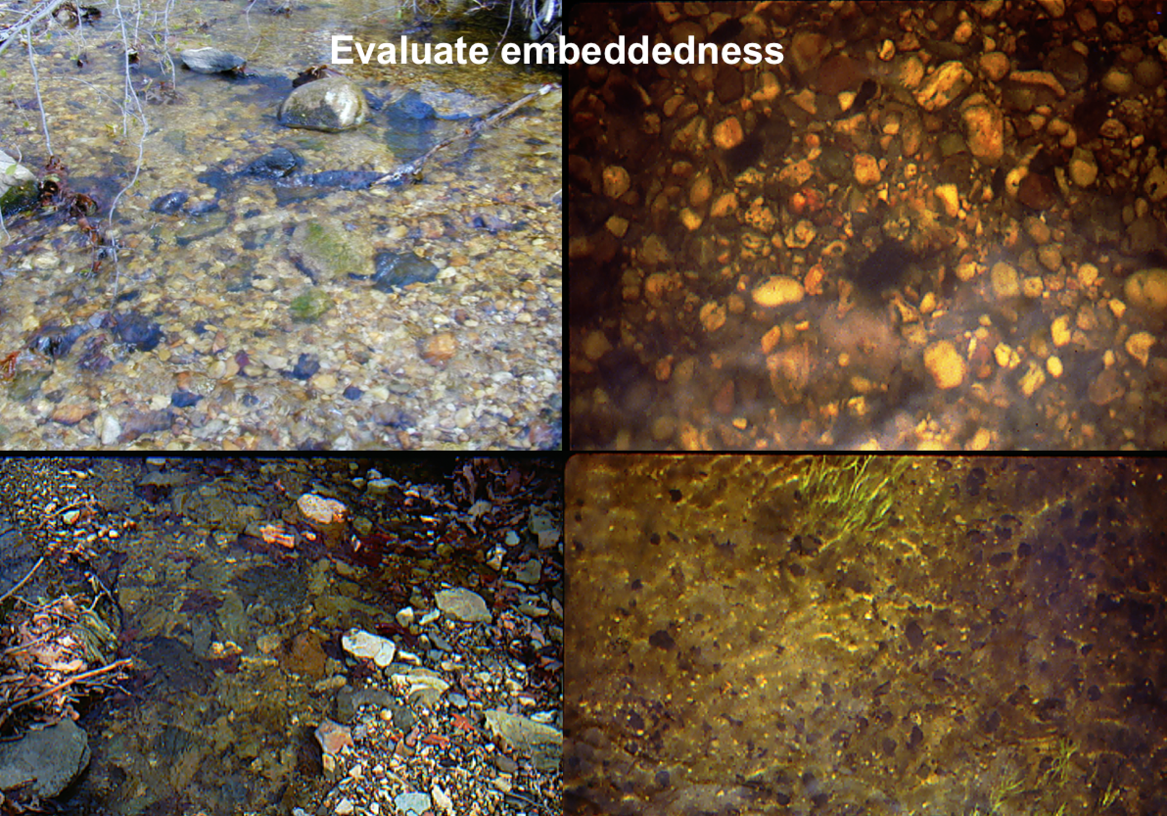

Figure : Background lecture material from the Audubon Society’s How to Read your Stream course [51]. This slide illustrates the difficulty of evaluating the embeddedness of cobbles in a stream. The EPA embeddedness scale is depicted in figure 3.

Issues encountered in training are also due to the ambiguity of the EPA protocol guidelines [44], which can be misleading. For instance, the embeddedness scale in Figure 2 rates optimal embeddedness as being less than 25% surrounded by fine sediment, suboptimal as being between 25 and 50% surrounded, 50-75% surrounded, and poor as 75-100% surrounded by sediment.

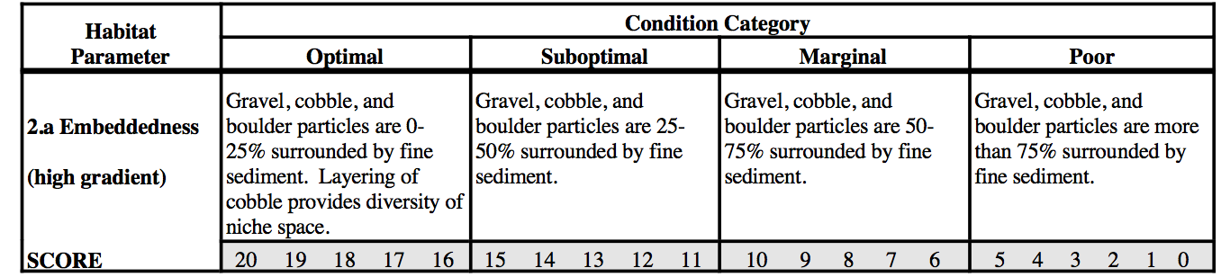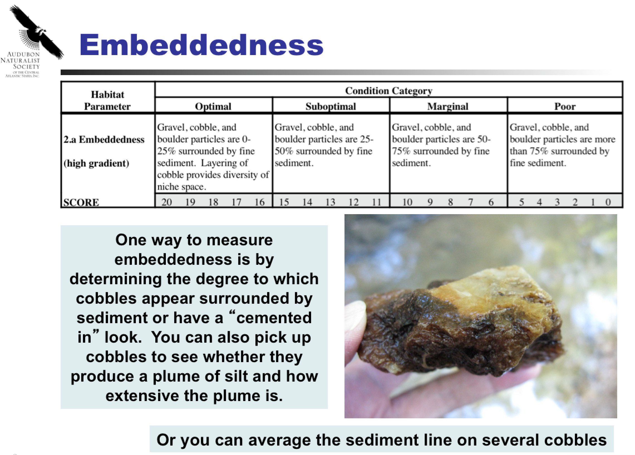

Figure : Lecture slide from the Audubon Society’s How to Read your Stream course [51], illustrating a scale to evaluate cobble embeddedness in streams as well as a close-up of embeddedness scale.

This suggests that the measure is linear, however expert clarification (G. Pond, Personal Communication, September 18, 2015) interprets areas more than 25% embedded as poor because the environment is unsuitable for macroinvertebrate organisms to thrive.

**THE VIRTUAL TRAINING ENVIRONMENT**

## Platform

Unity is a game development engine that supports the integration of virtual reality HMDs like Oculus Rift. Based on the design principles outlined in the section above, the training environment was designed in Unity 5 to reflect the EPA Bioassessment Protocol Guidelines [44], a monitoring standard commonly used by US water quality monitoring groups.In order to simulate realistic interactions, users interacted with the training environment using an Oculus Rift SDK1 and Xbox 360 Game Controller (see Figure 3).

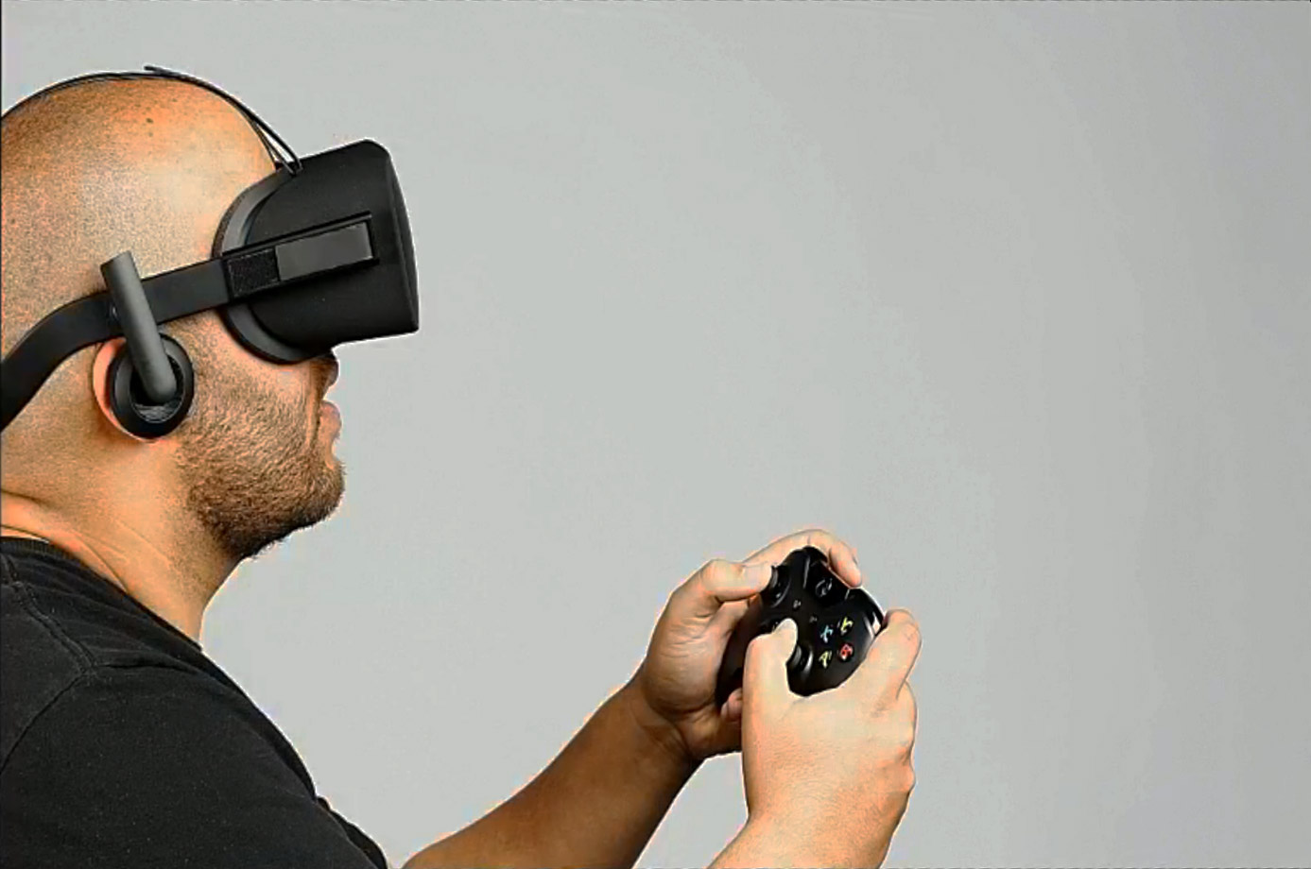

Figure : The Oculus Rift with the Xbox 360 controller. Together, the HMD and controller allow users to naturally interact with the virtual environment.

The virtual environment was modeled after an approximately 1.5 mile area of the Potomac river watershed, and constructed using a combination of brushes, shades, textures, sounds, assets and prefabs found in the Unity Asset store and online.

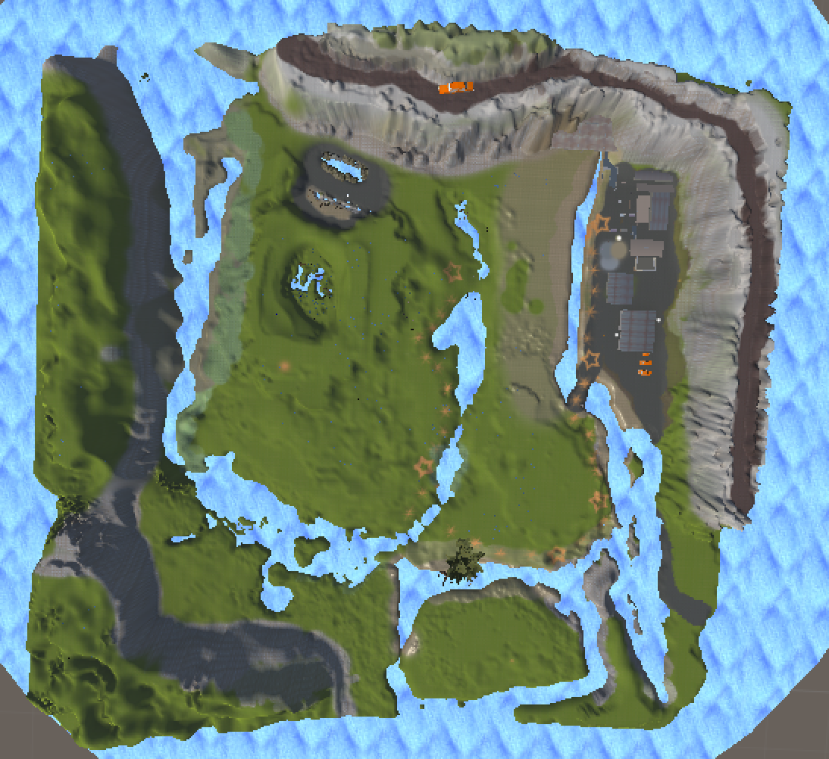

Figure . Top down view of the Potomac River Watershed virtual environment constructed in Unity 5.

**Protocol Assessment Parameters**

The goal of virtual training was help citizen scientists meaningfully learn to interpret standard water quality assessment protocols [44] [26] that were difficult to interpret from static images (e.g. [51]), but that were clearly defined by protocol.

Four of thirteen quality monitoring assessment parameters were chosen from the EPA Rapid Bioassessment Protocols[44] and simulated in the Unity virtual environment: *epifaunal substrate/available cover*, *bank stability*, *riparian vegetation zone width*, and *channel alteration*. These variables were chosen based on their relative impact on habitat (correlations to DV biological index scores)**(ref, greg’s PPT?)** and clarity of parameter assessment; as shown in Figure 2, some parameters were not linearly weighted and required gestalt assessment techniques not described directly in the protocol[1] (C. Wiss, Personal Communication, September 17, 2015)(G. Pond, Personal Communication, September 18, 2015).

**Optimal and Poor Environments**

Each of the four parameters was modeled in an optimal and poor environment based on principles described the EPA protocol guidelines [44]. For instance, Figure 5 shows a photo of optimal epifaunal substrate and a screenshot of the simulated environment, while Figure 6 shows a parallel photo and screenshot of poor bank stability.

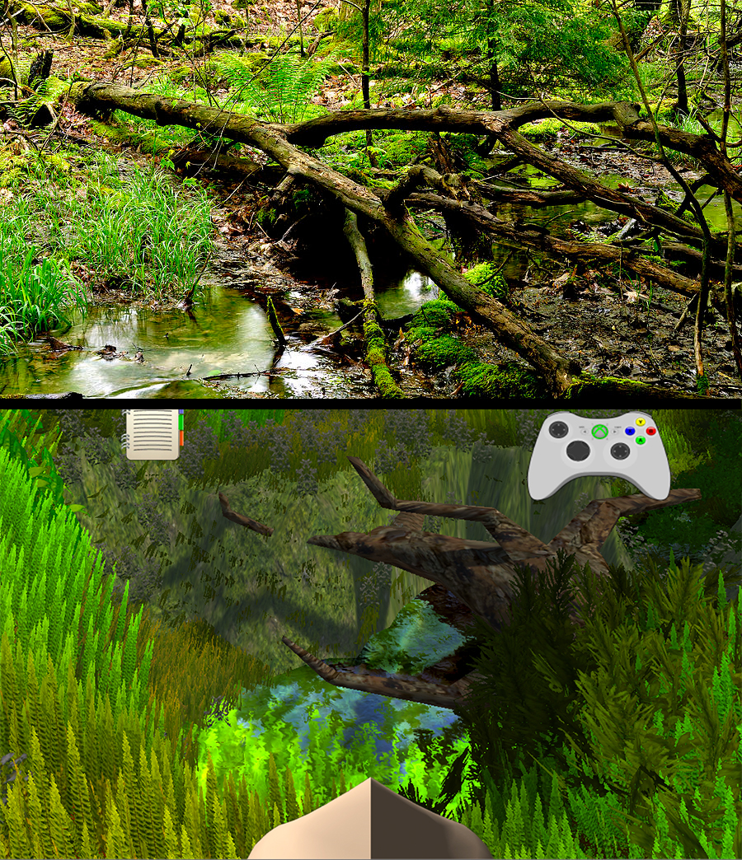

Figure : Optimal Epifaunal Substrate environment, shown in a live photo and in the Unity simulation. Both environments show an abundance of bank cover for fish and macroinvertebrate organisms that are made up of fallen logs, cobble and bank cover.

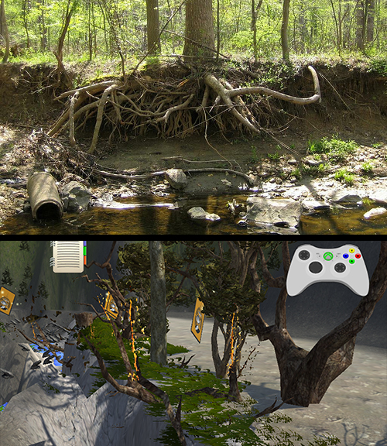

Figure : Poor Bank stability shown in a live photo and in the Unity simulation. Both environments show unstable, “raw” soil with high evidence of erosion and bank failure

**Interactions and Feedback**

***Tutorial Environment*** To help users meaningfully understand the parameters, a tutorial featuring an optimal and poor simulation stream was built to showcase the differences between the two environments. The optimal stream featured an abundance of epifaunal substrate, a large riparian zone, no channel alteration and stable banks, while the poor stream has no epifaunal substrate, a lack of a riparian zone, high channel alteration and highly eroded unstable banks.

Although the goal of the tutorial streams was to highlight the above four parameters, other protocol parameters were built into the environment to make the environment more realistic. The optimal stream contained a diversity of submerged vegetation, high sinuosity, a mix of deep and shallow pools with slow and fast velocities, and a variability of bugs and bug sounds around the stream. Meanwhile, the poor quality stream had sand and bedrock floor, a majority of standing pools, no sinuosity and a dearth of wildlife.

***Interactions*** During the training session, participants had the opportunity to explore each of the optimal and poor stream environments. Participants interacted with the tutorial by picking up cards containing either the protocol scale of a described parameter (Figure 7), or a definition of a stream characteristic. Participants picked up cards by bumping into them; the cards would zoom in front of participants, allowing them to study the protocol.

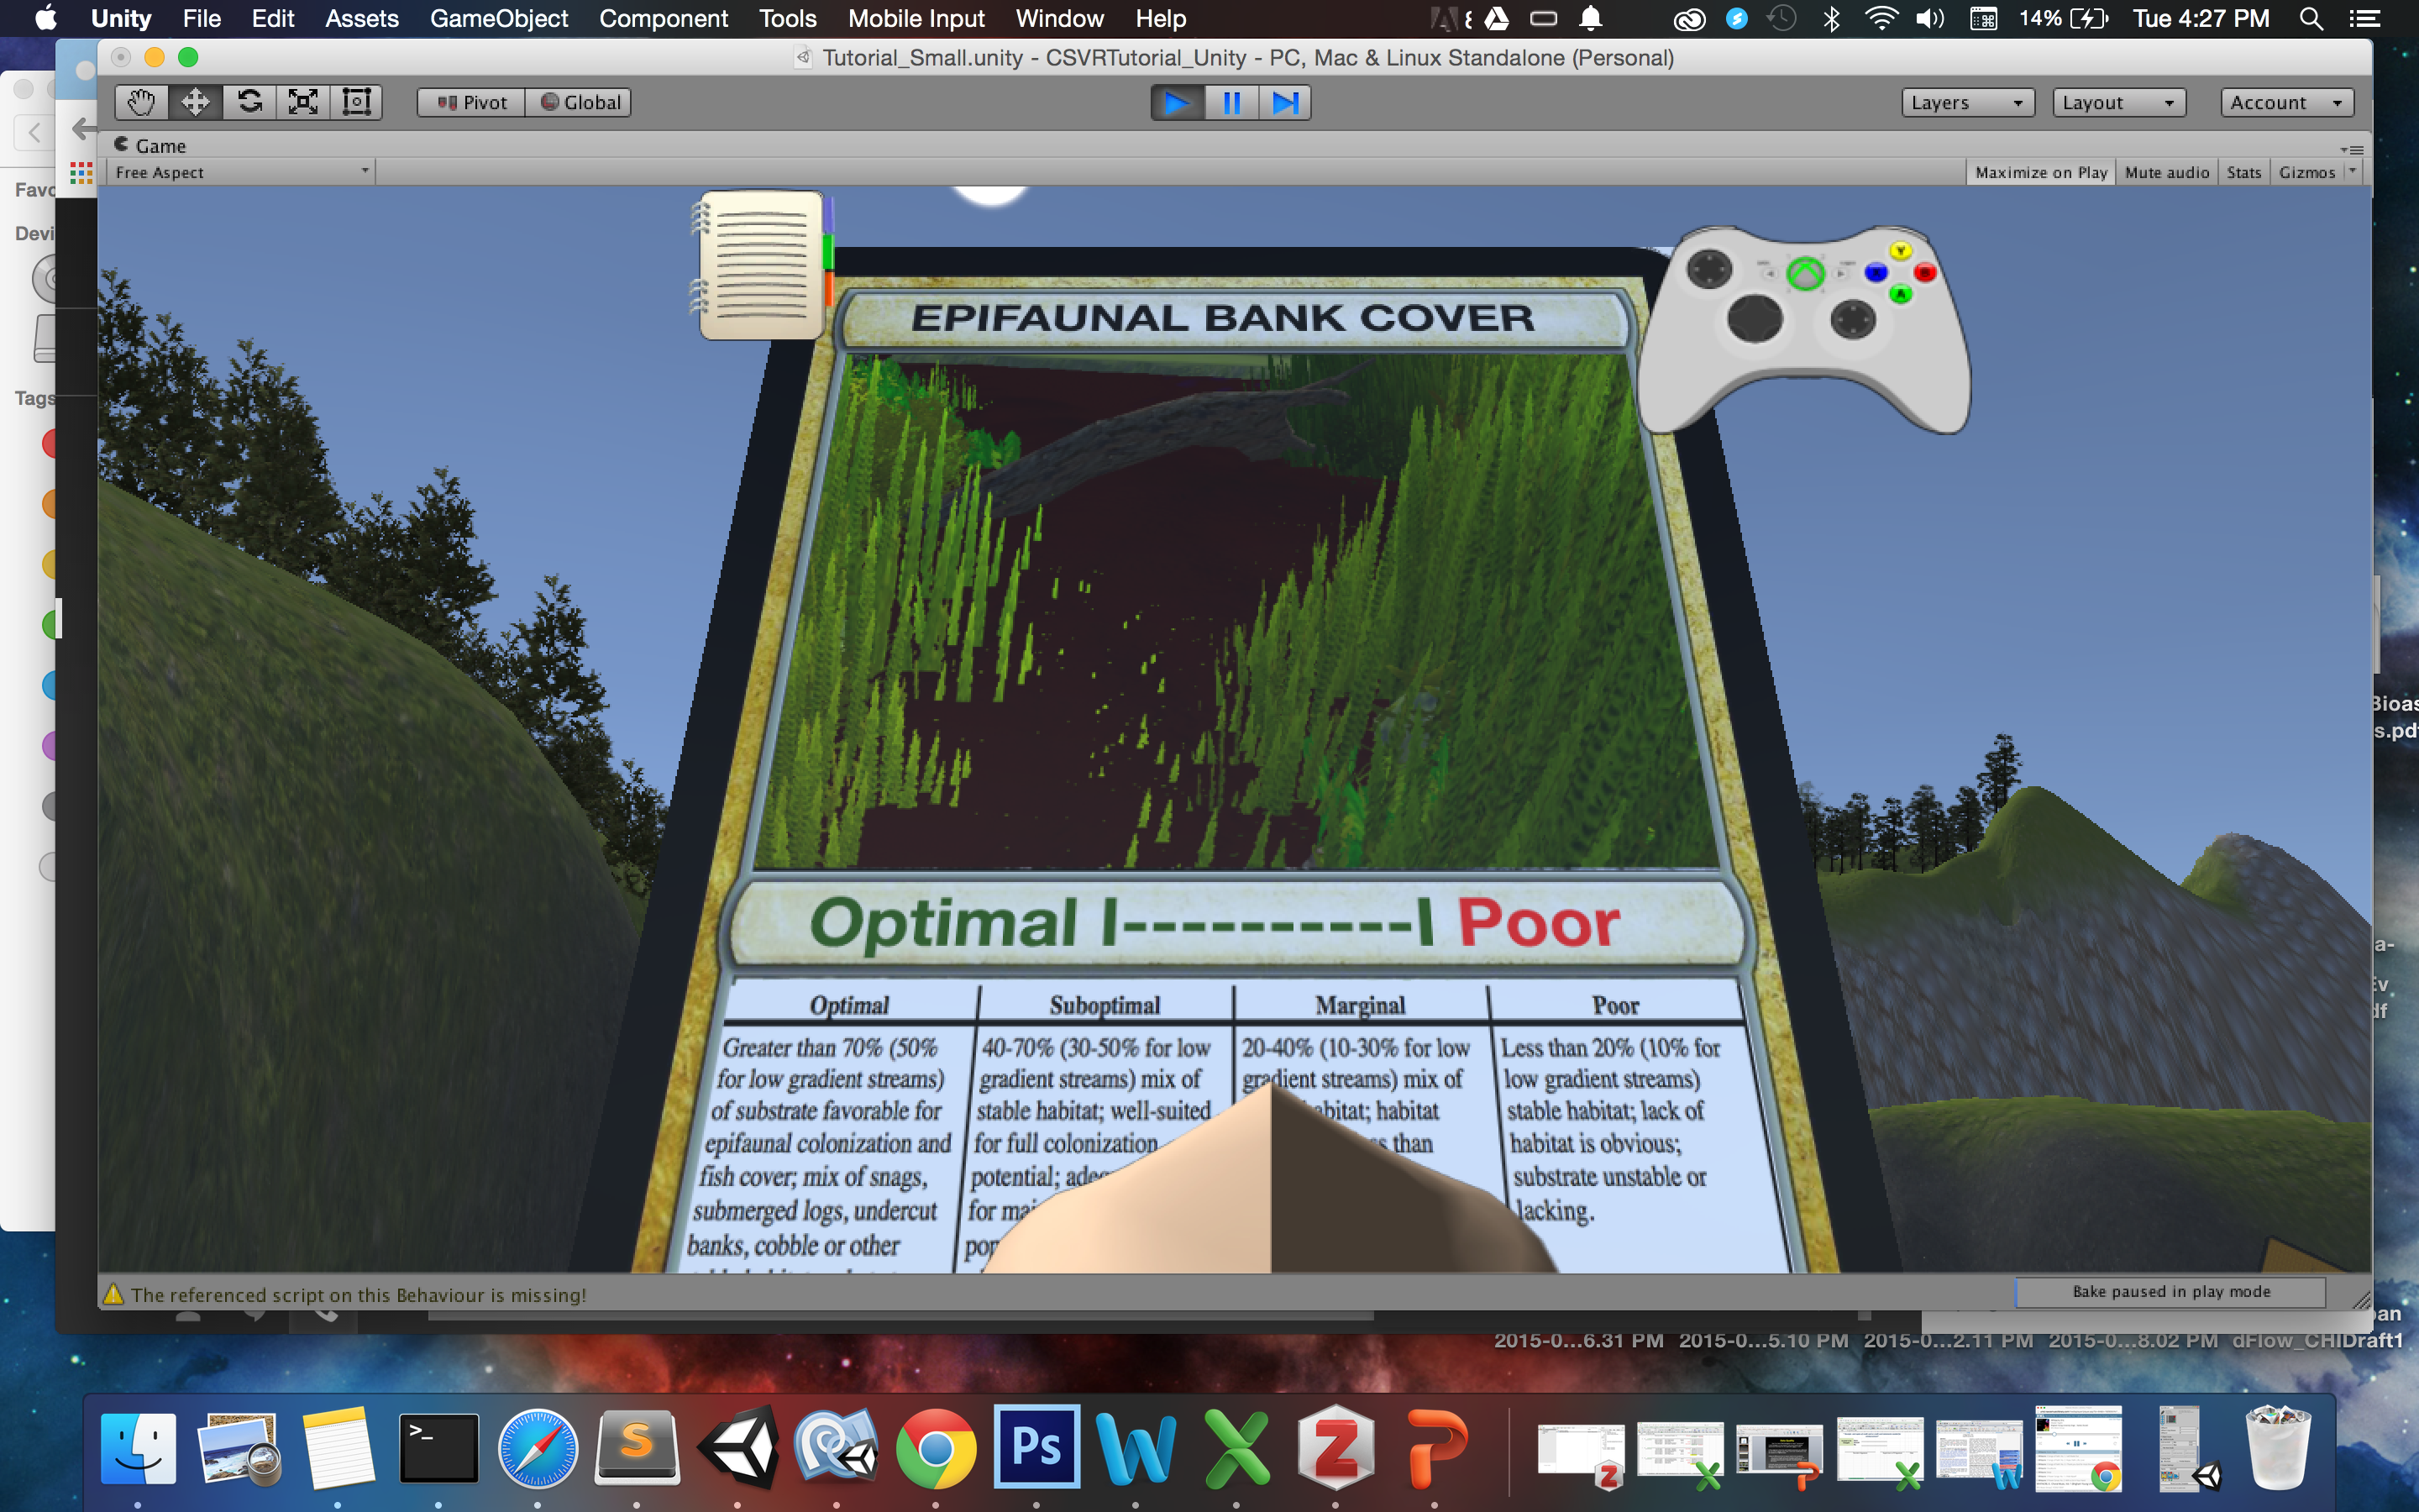

Figure : Close-up of training environment showing a first person perspective of Epifaunal bank cover protocol guidelines.

Once participants were satisfied with their understanding of the measure, they added them to their reference field guide notebook (Figure 8), which they could use to later make assessments. After a card was put into the their reference notebook, the virtual depiction of the parameter would glow in the stream, coaxing participants to physically interact with the measure.

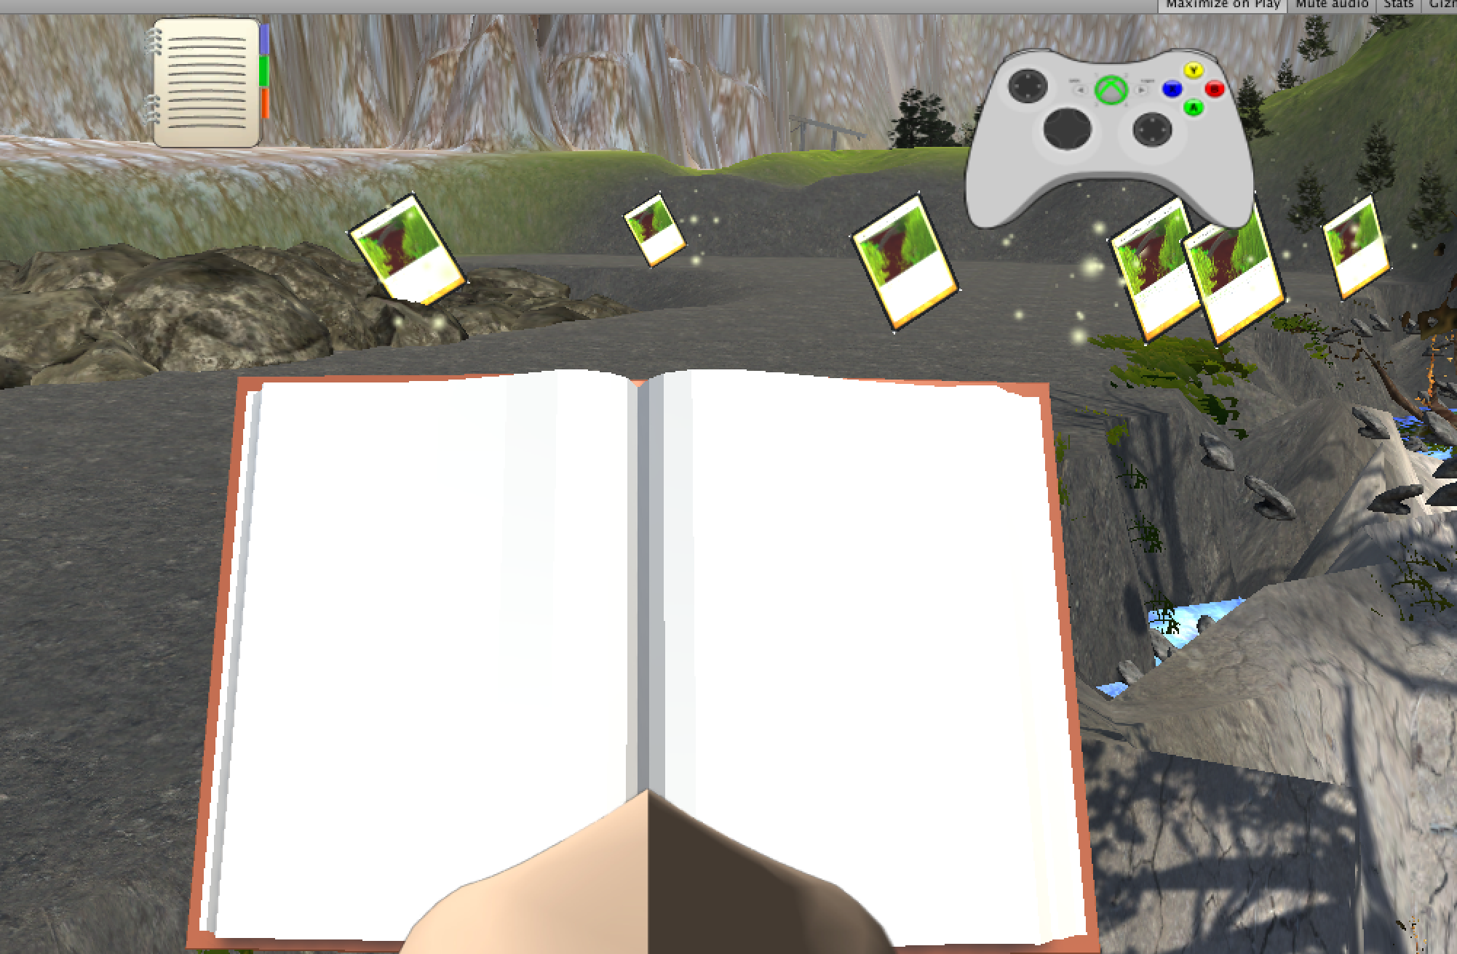

Figure : Close-up of field notebook containing collected cards containing protocol definitions and scales.

***Evaluation*** After fully exploring the optimal and poor environments, participants were asked to evaluate 3 virtual streams using the protocol they learned during the tutorial. Participants picked up assessment cards that were similar to the tutorial protocol cards, but which contained a viewfinder window **highlighting** an area of the stream to evaluate. Users made assessments by moving a slider over a number on the protocol scale. After making an assessment, the correct assessment range was highlighted on each card. While making their evaluations, participants had the opportunity to reference their collected field notebook images and scale descriptions.

**Evaluations and Feedback**



Figure : Assessment cards that participants used to assess the test streams based on the protocol they learned during training.

# Study Method

Participants were recruited from a pool of students taking classes at the University of Maryland who successfully passed a motion sickness pre-screening, and who consented to participate in the study. Participants interacted with a simulated training environment using a Oculus Rift HMD and integrated Xbox360 controller.

**Procedures**

***Virtual Training***

During the study, participants were guided through a tutorial showcasing virtual examples of optimal and poor water quality features **described above**. Afterthe tutorial, participants made assessments of those features in a sample virtual stream, receiving immediate feedback on their work. After completing the tutorial and immediate training, participants completed outdoor data on a stream on the University of Maryland campus.

At the beginning of the study, participants were introduced to the citizen science training protocol, and were asked to fill out a multicomponent questionnaire assessing their demographics, experience with citizen science, water quality monitoring, self-efficacy [22], games, and VR, and were asked to predict their enjoyment of the training and data collection tasks using the *Game Experience Questionnaire* (GEQ)[19].

Participants were given an Oculus Rift HMD and were guided through a tutorial[2] to make assessments of a virtual stream. After the tutorial, participants completed a short post-training survey measuring training engagement, flow, effectiveness, and nausea. Training engagement was measured using the GEQ, flow was measured using the *Flow Short Scale* (FSS)[36], and nausea was measured using the *Simulator Sickness Questionnaire* (SSQ)[20]. After completing the guided training tutorial, participants were challenged to make assessments about a virtual stream, an exercise during which they received immediate feedback on their performance, and again completed the post-training questionnaire.

*Outdoor Data Collection*

After training, participants were guided outdoors to assess a stream on the University of Maryland campus. Participants were asked to walk around the edge of the stream, and rate stream features based on protocol learned during virtual training**.** As during the assessment section of the training, participants were given a physical notebook that paralleled the reference guide they had during the virtual tutorial.

After outdoor data collection, participants were asked to complete a final survey measuring enjoyment, engagement and motivation during the task, as well as confidence in task performance. After the study, participants received verbal feedback on their outdoor assessment, and were debriefed about their experience.

# Results

This work asked to what extent the training environment integrated with virtual reality engaged participants and provided an overall state of immersion, whether the training led to accurate protocol evaluations, and whether participants were motivated to participate in future water quality monitoring projects. The research also examined whether individual differences affected perceptions of flow, task enjoyment, and motivation, and contributed to learning. The study gathered quantitative and qualitative data on participant experiences. Effective training was assessed by is measured by participant responses in the virtual and analog environments, and experience is measured by participant motivation and desire to participate in future data collection.

As this was a preliminary study, quantitative responses were used to make broad assessments of participants’ demographics, as well as engagement, immersion and motivation. Concurrent with answering questionnaires, participants were **intermittently** asked to assess their training experience during the study. Comments made during the training session were analyzed using qualitative open coding methods, and were triangulated with quantitative findings.

**[Results of Open coding]**

# Discussion

This work sought to understand whether a water quality monitoring training environment integrated with virtual reality engaged and immersed participants. Additionally this study sought to evaluate whether training in a simulated data collection environment was appropriate for water quality monitoring training.

[**[Discussion about Results]**

**Study Challenges**

Several challenges had to accounted for in this research, including motion sickness caused by VR, and the length of the study. Motion sickness has been well documented in the virtual reality community. The training aimed to diminish the effect of motion sickness by breaking up training into short tasks, and giving participants breaks between training. Whittinghall [7] has demonstrated that adding a virtual representation of the participant’s nose into the virtual reality environment may reduce motion sickness, so the training plans to also incorporate this feature into the VR interaction.

The length of the study was a secondary challenge and concern, which contributed to participant fatigue[23] and decrease flow [10]. Participants were asked to complete the background questionnaire prior to the study, however the research consisted of 3 training and testing protocols (including outdoor data collection), and 4 surveys.Daily computer use and self-efficacy may have thus affected user experience over the course of the study.

**CONCLUSION**

Showing the effectiveness of VR integrated into digital training has the potential to make training games more effective. Likewise, showing the effectiveness of this training in citizen science **has the potential to** revolutionize the field’s reach, improve quality, decrease training costs, and increase participant recruitment and retention.

**Future Work**

This work is a preliminary study to explore whether a virtual reality HMD integrated into a serious game is an effective way to train citizen scientists to make assessments about stream environments using the EPA Bioassessment protocol.

[This study found that **[results],** however our future work plans explore how the addition of a meaningful context and story contributes to engagement and quality of training, and quantitatively consider whether individual differences contribute to different perceptions of engagement, immersion and lead to differences in learning and motivation between subjects. Additionally, since this work explores virtual reality as a component of an effective learning environment, future work will compare participant outcomes in VR to parallel training with a desktop screen. Further, training outcomes could be compared to a passive training control reflecting PowerPoint lectures **given** by the Audobon naturalist society [51].

In additional to expanding the study, future work should explore how different sensory channels contribute to training immersion. For instance, studies might consider how smell, sound and touch may be used in training. Likewise, future research should examine how different narrative, feedback, and reward structure designs also impact how participants experience flow.

Although this study’s focus was college-age participants, citizen science has historically drawn older, more affluent volunteers [34]. Future work should thus also consider how this participant pool reacts to immersive virtual training. As well as addressing the needs of different populations, future work might additionally address whether immersive virtual reality training is appropriate for a broader scope of citizen science projects [49], such as virtual, conservation or education projects.

# Acknowledgements

# <<leave out for reviewing but then include, Greg, Audobon lady, everyone who comments on drafts

# REFERENCES

1. Audubon Naturalist Society (2012). *Water Quality Monitoring (WQM*). Retrieved from http://www.anshome.org/index.php/nature-programs/water-quality-monitoring
2. Audubon Naturalist Society (2012). *Water Quality Monitoring “Part of Our DNA,”* Retrieved from http://www.anshome.org/images/waterquality/Water%20Quality%20Monitoring.pdf
3. Barnes, T., Powell E., Chaffin, A., & Lipford, H. (2008) Game2Learn: improving the motivation of CS1 students, *Proceedings of the 3rd international conference on Game Development in Computer Science Education*, p.1-5, February 27-March 03, 2008, Miami, Florida.
4. Batini, C., Cappiello, C., Francalanci, C., Maurino, A. (2009). Methodologies for Data Quality Assessment and Improvement, *ACM Computing Surveys*, Vol. 41, No. 3, Article 16
5. Bonney, R., Cooper, C.B., Dickinson, J., Kelling, S., Philips, T., Rosenberg, K., Shirk, J.(2009). Citizen Science: A Developing Tool for Expanding Science Knowledge and Scientific Literacy, *BioScience*, Dec 2009 : Vol. 59, Issue 11, pg(s) 977-984
6. Boyle, EA, Connolly, TM, Hainey, T. & Boyle, JM 2012, ‘Engagement in Digital Entertainment Games: A Systematic Review’, *Computers in Human Behavior*, vol. 28, pp. 771-80
7. Braunstein, J (2015). Is the answer to simulator sickness right in front of our nose? *UploadVR.com*, Retrieved from http://uploadvr.com/is-the-answer-to-simulator-sickness-right-in-front-of-our-nose/
8. Brockmyer, J.H., Fox, C.M., Curtiss, K.A., McBroom, E., Burkhart, K.M., Pidruzny, J.N. (2009), the development of the Game Engagement Questionnaire: A measure of engagement in video game-playing *Journal of Experimental Social Psychology* 45 (2009) 624–634
9. Csikszentmihalyi, M. (1990). [*Flow: The Psychology of Optimal Experience*](http://books.google.com/books?id=V9KrQgAACAAJ)*.* Harper & Row
10. Chen, J. (2007). Flow in Games (and Everything Else), *Communications of the ACM*, Vol. 50, NO. 4.
11. Cohn, J. (2008). Citizen Science: Can Volunteers do Real Research? *Bioscience*, 58(3): 192-197.
12. Decker, A., Lawley, E.L. (2013). Life’s a Game and the Game of Life: How Making a Game Out of it Can Change Student Behavior. *SIGCSE’13*, March 6–9, 2013, Denver, Colorado, USA.
13. Ermi, L., & Mayra, F. (2005). Fundamental Components of the Gameplay Experience: Analyzing Immersion, *2005 Digital Games Research Association’s Second International Conference*, pp. 15–27
14. Everleigh A., Jennett, C., Blandford, A., Brohan, P., & Cox, A (2014). Designing for Dabblers and Deterring Drop-Outs in Citizen Science. *CHI 2014*, April 26–May 1, 2014, Toronto, Ontario, Canada.
15. Garris R., Ahlers R., & Driskell, J. (2002). Games, motivation and learning: a research and practice model. *Simulation & Gaming*, Vol. 33, No. 4, 2002, 441-467
16. Goldman, A. (2014). Predicting and Motivating Achievement in Self-Paced Learning. *Master's Thesis*, University of Maryland, College Park
17. Hansen, S. (2014), Urban kids, urban waterways: Citizen science improves lives and environment, Shorelines, *Life and Science at the Smithsonian Environmental Research Center*. Retrieved from http://sercblog.si.edu/?p=5467
18. Herron, E., Stepenuck, K., & Green, L. (2008), *From the Trenches: Tips and Tools for Better Presentations*, Retrieved from http://www.usawaterquality.org/volunteer/pdf/GuideBook/PresentationsX.pdf
19. IJsselsteijn, W. A., Poels, K., & de Kort, Y. A. W. (n.d.). The game experience questionnaire: Development of a self-report measure to assess player experiences of digital games, manuscript in preparation.
20. Kennedy, R.S., Lane, N.E., Berbaum, K.S., & Lilienthal, M.G. (1993). Simulator Sickness Questionnaire: An enhanced method for quantifying simulator sickness. *International Journal of Aviation Psychology*, 3(3), 203-220
21. Klemmer, S., Hartmann, B., & Takayama, L. (2006). How Bodies Matter: Five Themes for Interaction Design, *The Conference on Designing Interactive Systems (DIS),* June 26–28, 2006, University Park, Pennsylvania.
22. Klobas, J., Renzi, S. and Nigrelli, M.L. (2007).  A scale for the measurement of self-efficacy for learning (sel) at university.  *Dondena Working Papers*.  Carlo F. Dondena Centre for Research on Social Dynamics. Retrieved from [www.dondena.unibocconi.it/wp2](http://www.dondena.unibocconi.it/wp2).
23. Kiili, K., Lainema, T., de Freitas, S., Arnab, S. (2014).

Flow framework for analyzing the quality of educational games, *Entertainment Computing*, 5 (2014) 367–377

1. Lee, J. J., & Hammer, J. (2011). Gamification in Education: What, How, Why Bother? *Academic Exchange Quarterly*, 15(2).
2. Lemay, P (2007). Developing a Pattern Language for Flow Experiences in Video Games. *Situated Play, Proceedings of DiGRA* 2007 Conference, 449-455.
3. Maryland Department of Natural Resources (2009), *Maryland Biological Stream Survey*, January 2009. Retrieved from <http://www.dnr.state.md.us/streams/pdfs/R4Manual.pdf>
4. “Meet your Watershed”(2015). Blue River Watershed Association, <http://www.brwa.net/watershed.htm> [Retrieved, September 19, 2015]
5. McMahan, A. “Immersion, Engagement, and Presence: A Method for Analyzing 3-D Video Games”, in Wolf, M.J.P., and Perron, B. (eds.). *The Video Game Theory Reader.* Routledge, New York, 2003, pp. 67–86.
6. Moran, S., Pantidi, N, Tom Rodden, T.,Chamberlain, A., Griffiths C., Zilli, D., Merrett, G., and Rogers, A. (2014). Listening to the Forest and its Curators: Lessons Learnt from a Bioacoustic Smartphone Application Deployment, *CHI 2014*, April 26–May 1, 2014, Toronto, Ontario, Canada.
7. Nacke, L., & Lindley, C.A. (2008). Flow and Immersion in First-Person Shooters: Measuring the Player’s Gameplay Experience, *FuturePlay 2008*, November 3-5, 2008, Toronto, Ontario, Canada
8. Nacke, L, Nacke, A., & Lindley, C.A. (2009). Brain Training for Silver Gamers: Effects of Age and Game Form on Effectiveness, Efficiency, Self-Assessment, and Gameplay Experience, *CyberPsychology & Behavior* 12(5), p. 123-140.
9. Nielson, J (1995). Ten Usability Heuristics for User Interface Design, Retrieved from [www.nngroup.com](http://www.nngroup.com)
10. Pond, G, Passmore, M., Borsuck, F., Reynolds, L, Rose, C. (2008). Downstream effects of mountaintop coal mining: comparing biological conditions using family- and genus-level macroinvertebrate bioassessment tools, *The North American Benthological Society,* Retrieved from http://www.epa.gov/region03/mtntop/pdf/downstreameffects.pdf
11. Raddick, M., Bracey,G., Gay, P., Lintott, C., Murray, P., Schawinski, K., Szalay, A. & Vandenberg, J. (2010) Galaxy Zoo: Exploring the motivations of citizen science volunteers. *Astronomy Education Review*, 9(1).
12. Rae, I., Venolia, G., Tang J.C., & Molnar, D. A Framework for Understanding and Designing Telepresence, in Proc. *CSCW 2015, ACM – Association for Computing Machinery*, 14 March 2015
13. Rheinberg, F., Vollmeyer, R., & Engeser, S. (2003). The assessment of flow experience. In J. Stiensmeier-Pelster & F. Rheinberg (Eds.), *Diagnosis of motivation and self-concept* (pp. 261–279). Go¨ttingen: Hogrefe.
14. Rotman, Hammock, J., D., Preece, J. Boston, C., Hansen, D., Bowser, A., He, H. (2014). Does Motivation in Citizen Science Change with Time and Culture? *Conference on Computer-Supported Cooperative Work and Social Computing (CSCW):* Feb 15-19 2014, Baltimore, MD, USA
15. Rotman, D., Preece, J., Hammock, J., Procita, K., Hansen, D.L., Sims, C., Parr, S., Lewis, D., Jacobs, D.W. (2012). Dynamic changes in motivation in collaborative citizen science projects. *Conference on Computer-Supported Cooperative Work and Social Computing (CSCW):* 217-226
16. Seymour, N.E., Gallagher, A.G.,Roman, S.A., O’Brien, M.K., Andersen, D.K., Sataya, R.M. (2002). Virtual Reality Training Improves Operating Room Performance Results of a Randomized, Double-Blinded Study, *Annals of Surgery*, 2002 Oct; 236(4): 458–464. Retrieved from http://www.ncbi.nlm.nih.gov/pmc/articles/PMC1422600
17. Sheppard, S.A., & Terveen, L. (2011). Quality as a Verb: the operationalization of data quality in a citizen science community.  *International Symposium on Wikis and Open Collaboration (WikiSym*), Mountain View, California
18. Shernoff, D. J., & Csikszentmihalyi, M. (2009). Flow in schools: Cultivating engaged learners and optimal learning environments. In R. Gilman, E. S. Huebner, & M. Furlong (Eds.), *Handbook of Positive Psychology in Schools* (pp. 131-145). New York: Routledge. Retrieved from http://www.cedu.niu.edu/~shernoff/shernofffsc.pdf
19. **Taylor, A-S.,** Backlund, P. (2011). Letting the students create and the teacher play: Expanding the roles in serious gaming. In Proceedings of the Academic Mind Trek conference (MindTrek'11, pp. 63–70, Tampere, Finland, September 28-30, 2011.
20. Tenenbaum, G., Fogarty, G., & Jackson, S. (1999). The flow experience: A Rasch Analysis of Jackson’s Flow State Scale*. Journal of Outcome Measurement,* 3(3), 278- 294.
21. US Environmental Protection Agency(1999), *Rapid Bioassessment Protocols for Use in Wadeable Streams and Rivers, 2nd Edition* www.epa.gov/OWOW/monitoring/rbp/wp61pdf/rbp.pdf
22. Velikovsky, JT (2014). Flow Theory, Evolution & Creativity: or, ‘Fun & Games,’ *IE2014*, December 02-03, Newcastle, NSW, Australia
23. Water Quality Conditions (Chapter 5): Quality Assurance, Quality Control, and Quality Assessment Measures (2012). *Environmental Protection Agency* Retrieved from <http://water.epa.gov/type/rsl/monitoring/vms50.cfm>
24. “Water Quality E-Learning,” *South Carolina Oyster Restoration and Enhancement (SCORE).* Retrieved from http://score.dnr.sc.gov/deep.php?subject=5&topic=11
25. Wiggins, A. (2013). Free as in puppies: compensating for ict constraints in citizen science. *Proceedings of CSCW*, Pgs. 1469-1480
26. Wiggins, A. & Crowston, K. (2011). [From Conservation to Crowdsourcing: A Typology of Citizen Science](http://andreawiggins.com/wp-content/uploads/2013/10/Wiggins2011HICSS.pdf). In *Proceedings of the 44th Annual Hawaii International Conference on System Science (HICSS-44)*
27. Wiggins, A., Newman, G., Stevenson, R. D., and Crowston, K. (2011). Mechanisms for data quality and validation in citizen science. In *Proceedings of Workshops at the Seventh International Conference on eScience, IEEE*, 14–19
28. Wiss, C. (2014), How to Read Your Stream, *Audubon Naturalist Society*

1. Future studies should explore how to train measures poorly described by protocol, however this was beyond the scope of this research.
2. The virtual training tutorial, guided data collection, and test consisted of 5-10 minute sessions in order to prevent motion sickness and cognitive overload.